AM000-Asia-China-Warring States-Mirror-5 T-Bronze-

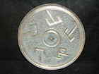

[chinese Warring States "Mountain" word Bronze Mirror](http://www.ebay.com/itm/390355902199?ssPageName=STRK:MEWNX:IT&_trksid=p3984.m1439.l2649) (390355902199)

Sale date: 04/28/12

Tracking number: --

Estimated Delivery: 05/15/12 - 05/29/12

$120.00

+ $27.00